Reinforcement

Background
Reinforcement follows a basic law, which states that living organisms tend to repeat those behaviors that result in reward and avoid those behaviors that fail to produce rewards. The two major types of reinforcement are positive and negative. In positive reinforcement, a stimulus (or reinforcer) is presented in consequence to a child behavior. A positive reinforcer is anything that, when presented as a consequence of a behavior, results in an increase or maintenance of that behavior (e.g., we get paid for working). In contrast, when an aversive stimulus is removed in consequence to a child behavior, negative reinforcement is being used; a negative reinforcer increases the frequency or strength of a behavior, in order to avoid or escape an aversive stimulus (e.g., we wear seat belts to avoid getting tickets). While positive reinforcement is more widely used in the classroom, it is important to remember that both procedures should result in maintenance or an increase in the desired behavior.
There are two types of reinforcers, primary and secondary reinforcers. Primary reinforcers are temporary measures to enable rapid acquisition of appropriate behavior. They are stimuli that have biological importance to an individual. We can assume that they are innately motivating because they are necessary to the perpetuation of life. For primary reinforcers to be effective, the child must be in a state of deprivation in relation to that reinforcer (e.g., a food reinforcer will only be effective if the child is hungry). At the beginning of a 20-minute activity, a child may be hungry and find edibles reinforcing. Once the child has been reinforced a number of times, satiation may occur. The hunger that was present at the beginning of the activity no longer exists; therefore, edible items are not as effective as reinforcers.
Primary reinforcers should eventually be replaced by secondary reinforcers. Secondary reinforcers do not have biological importance to individuals. Their value has been learned or conditioned. They include social stimuli, such as words of praise, the opportunity to engage in a preferred activity, and a symbolic representation, such as a token, which is exchangeable for another reinforcer.

Type | Definition | Examples
Edible | Desired foods and liquids (e.g., pieces of cracker, raisins, sips of juice). Edible reinforcers are used mainly when teaching new behaviors to younger children. Because of their high motivational value, they quickly affect behavior. Be aware of food allergies or dietary restrictions when selecting edible reinforcers. | Grocery shopping can be very difficult with a 2-year-old child. For this reason, Kim usually stayed home with her father when her mother shopped. One afternoon, her father was not available, and Kim accompanied her mother to the store. Knowing that Kim would try to climb out of the cart, her mother was prepared with Kim’s favorite treat, Fruit Loops cereal. Kim was placed in the cart and immediately given a Fruit Loop paired with the words. “I like how you’re sitting in the cart like such a big girl”. This reinforcement occurred every few minutes. Kim learned that she was expected to sit in the cart and her mother was able to complete her shopping list.
Sensory | Events that provide naturally occurring sensations that may be reinforcing stimuli to some children.  Sensory reinforcers include:  Auditory: songs, musical instruments, story time, conversation with others  Visual: mirrors, kaleidoscopes, magazines and pictures of familiar people, bubbles  Olfactory: scented lotions, various spices, scratch and sniff stickers  Tactile: manipulating textures, tickles, air from a fan or hair dryer, lotion, water play, “give me five”  Proprioceptive: bounce, swing, and rock  Thermal: sitting by air conditioners/heaters, ice packs/heating pads  Vestibular: throwing/bouncing a ball, dancing, roller skating, swimming, running | Examples: Fine motor tasks are not very enjoyable for Sean, but proprioceptive activities are. One of his goals is to complete a 4-piece puzzle. His teacher has worked out a system with Sean that every time he correctly places a piece in the puzzle, he is able to jump on the trampoline 10 times. Within a short amount of time, the teacher’s expectations of Sean increased from completing 2 pieces to 3 pieces, and eventually all 4 pieces before he was able to access the trampoline.
Social | Verbal or physical interactions demonstrating approval or attention. These include expressions, proximity, contact, words, and phrases. One important aspect of social reinforcement is to use specific praise (e.g., “I like the way you covered your mouth when you sneezed”) rather than general praise (e.g., “Good job”). The former places the emphasis on the behavior and not on the child himself. This helps the child to focus on specific aspects of his behavior. | “Johnny, I like the way you’re building with the blocks.”  The teacher said, “Doug, you can be the line leader because you were so quiet when I read the story.”
Activity | An activity that a child enjoys that can be used as a reinforcer for a desired response. These reinforcers are much more natural and not as intrusive as some other reinforcers in a classroom situation. | Susie’s mother tells her that she may watch her favorite video as soon as she has finished eating her lunch.  Monique tells her class that they can play outsides soon as they pick up all of the toys.
Tangible | Objects that a child can use or manipulate (e.g., toys, fidgets) or collect (e.g., stickers, cards). These can be very effective if selected based on the child’s desire for that object. Caution must be used with tangible reinforcers as the child can become satiated. | Because her husband is working, Mary must take both of her young children to temple by herself. Sarah, her 4-year-old, usually behaves quite well. To maintain that good behavior, each time she behaved well in temple, they made a trip to the store and Sarah was allowed to select a new key chain for her collection.  Nancy was teaching several children in her class to use the toilet. She posted a chart for each child in the bathroom. Every time one of the children used the toilet successfully, they placed a sticker on the chart. At the end of the day, they were able to take their stickers home.
Token board | Uses reinforcers that are exchangeable for objects or activities that have reinforcing properties for the individual. One major advantage of this type of reinforcer is that it can be delivered immediately and represents the fact that a more powerful reinforcer is forthcoming. A token must be delivered immediately and consistently, or it will lose its reinforcing value. The use of tokens presupposes the child’s ability to “wait” and to connect tokens with a later reinforcer. | Each child in Ann’s class had individual goals and objectives. One way to reinforce a variety of different behaviors was to have a classroom reward system. In the classroom, a bulletin board was decorated with 10 large apples. Each apple had a child’s name on it. Whenever a child did something that Ann wanted to reinforce (i.e., shared a toy, covered their mouth when they sneezed), she gave them a sticker to place on their apple. Before they went home each day, the children counted their stickers. As soon as they earned a predetermined number of stickers, they were able to trade in their apple for a treat in the “prize bucket”.

Guidelines
The following guidelines from Hardy & McLeod (2020) should be followed when planning to use reinforcement.
- Determine child preferences by observing the child, asking the child about their preferences, or conducting a preference assessment. You can also provide children with opportunities to choose their reinforcer, such as through use of a choice board.
- Use a variety of potential reinforcers. First, consider what will be effective for reinforcing the desired behavior. Use natural, rather than contrived, reinforcers when possible. When using contrived reinforcers, pair them with more natural reinforcers. Finally, use the least intrusive reinforcer possible.
- Consider children’s strengths and needs. There are several components to considering strengths and needs.
  - Provide reinforcement contingent on children’s effort. For example:
Darius’s clean-up behaviors might be reinforced when he cleans up dramatic play by himself without help, while Suzie’s clean-up behaviors might be reinforced when she puts three blocks on the shelf in the block center. This is because Darius and Suzie have different skill levels and needs related to cleaning up. (Hardy & McLeod, 2020, p. 8)
  - Reinforcement should be provided immediately after the behavior being reinforced. For reinforcers that are impractical to provide immediately, you can use a token board so the child receives a token after the desired behavior that can later be exchanged for the reinforcer.
  - Consider children’s receptive language abilities when using descriptive praise.
Descriptive praise such as “Simone, you did a great job using walking feet in the hallway. That keeps you safe!” might be appropriate for Simone, but for a child with receptive language delays, a comment such as “Nice walking!” might be more appropriate, and, importantly, still describes the child’s appropriate behavior. (Hardy & McLeod, 2020, p. 9)
- Use reinforcement strategically. This means you should reinforce behaviors regularly when first teaching a skill to a child but move to intermittent reinforcement as the child makes progress at learning the skill. Eventually, the child should demonstrate the behavior consistently and receive reinforcement for the behavior at rates similar to their peers.
- Embed reinforcement in routines and activities. Provide multiple authentic opportunities for children to demonstrate desired behaviors and have those behaviors reinforced. Consider using an activity matrix to plan reinforcement opportunities.
- Consider the role of relationships. Reinforcement should not replace authentic relationships with children. Make sure to build relationships with children through conversations, play, learning about their family and culture, and showing interest in their lives and experiences. Also make sure to use reinforcement with all children, even those that struggle with engaging in appropriate behaviors.
- Collaborate with families. Communicatee with families about their priorities and concerns when identifying desired behaviors to target for instruction and thus reinforce. Importantly, consult with families before using edible reinforcement.

The following flowchart can be used to guide decision-making.

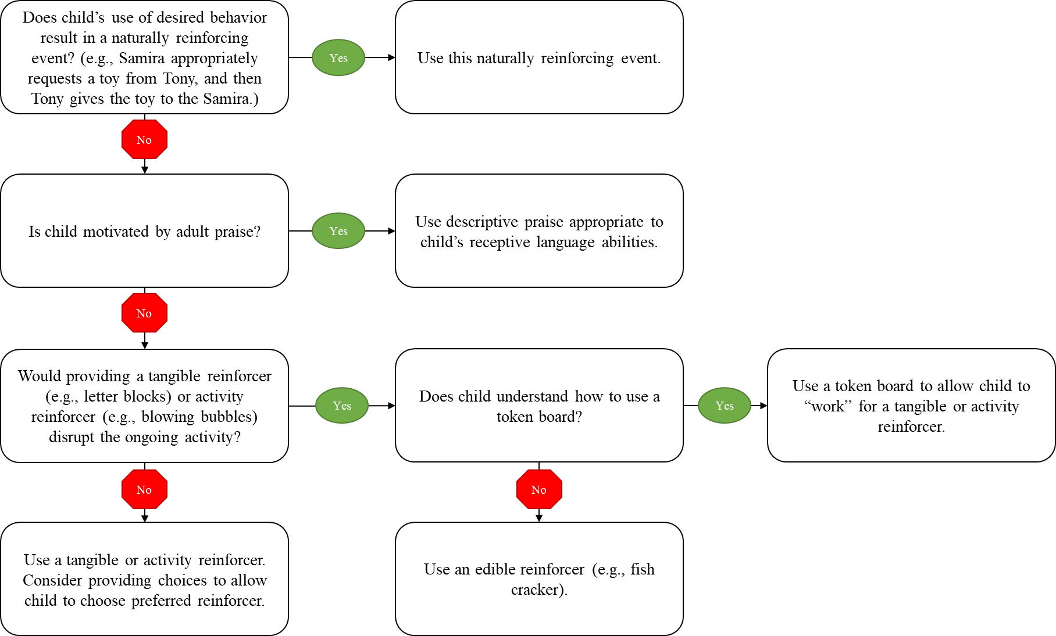

Microteach Instructions

- Select a developmentally appropriate behavior or skill that needs to be learned.
- Make a plan for implementing the above guidelines to reinforce the desired behavior or skill.
- Follow general microteach procedures.

