Triadic Strategies

Background
A characteristic of successful early intervention is the extent to which families are supported as confident and competent caregivers. An important consideration in supporting families in this manner is to acknowledge and build on the strengths of the caregiver-child dyad. Sensitive and trusting caregiver-professional relationships are essential. The triadic intervention model pays explicit attention to relationships between parents (or other caregivers), children, and interventionists, with the focus on the interactions of parent-child dyads.
Intervention facilitators from various disciplines can support and enhance caregiver-child interactions by consciously planning and implementing triadic strategies. Triadic strategies build upon parents’ natural skills and facilitate the development of new competencies. Intervention using triadic strategies serves to enhance pleasurable, dyadic interactions, which, in turn, promote children’s development. Triadic strategies can be used in a variety of settings, such as home visits, parent-child groups, and therapy sessions.

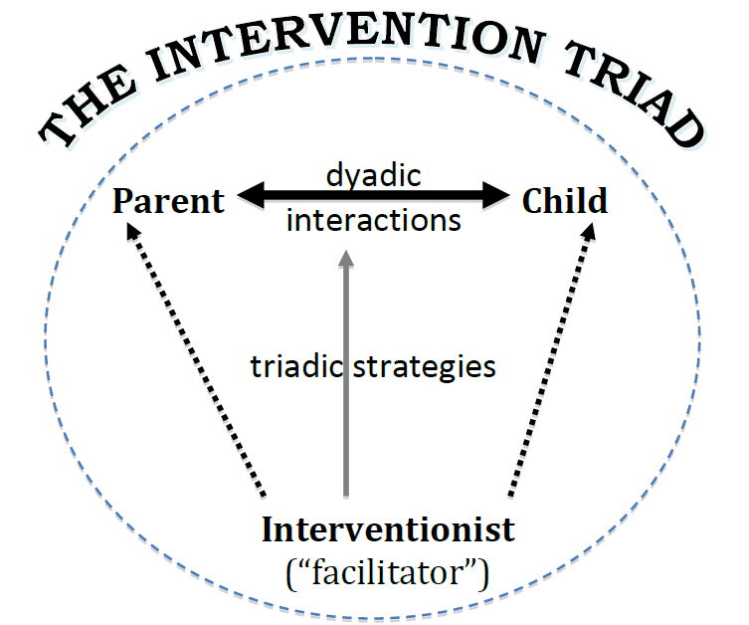
Guidelines
The six triadic strategies are on a continuum from least direct to most direct. You should use the directive strategies last and least often. A less directive strategy may be all that is needed to enhance a particular interaction. A guiding principle is to wait and observe after implementing each strategy to determine what, if any, additional strategies might be appropriate. Use of the triadic strategies serves to facilitate application of the dyadic strategies by the adult with whom you are interacting.
- Strategy 1: Establish dyadic context - Elements of the environment are arranged or rearranged to increase the probability of developmentally-matched, mutually enjoyable caregiver-child interaction.
  - The facilitator provides intervention directly via the adult:
    - Provide an activity that supports both partner’s participation.
    - Provide a toy, material, or activity that encourages interaction. For example, roll a ball to the dyad.
    - Position the child so that the adult can observe what the child is doing.
    - Help the child bring and position materials in front of the adult.
    - Move a toy closer to where the adult is sitting.
    - Move yourself away from the child so that the adult interacting with the child is closer.
  - Facilitator provides intervention indirectly through the child:
    - Help child bring toys to the adult.
    - Say to or for the child:
      - “Where’s Mom? I bet Mommy would like to see this”
      - “Let’s show Dad the telephone.”
      - “Caregiver’s name, will you help me with this?”
- Strategy 2: Affirm parenting competence - Developmentally supportive interactions are warmly recognized and expanded upon, as are characteristics of child competence.
  - Facilitator provides intervention directly via the adult:
    - Say to the adult:
      - “He really likes to play with you like that.”
      - “She sure looks at you when you imitated her.”
      - “When you pushed on it, she imitated you.”
      - “That was a good idea to move it closer.”
      - “You asked about ______. I brought you some information.”
  - Facilitator provides intervention indirectly through the child:
    - Say to or for the child:
      - “Mom really likes to watch you.”
      - “I like it when you do that, Dad.”
      - “Look how I can do this after you showed me how.”
      - “Thanks, Dad, that helped.”
- Strategy 3: Focus attention - Aspects of the interaction are commented upon, expanded, or questioned to draw the parent’s attention to particular competencies or actions in self or child.
  - Facilitator provides intervention directly via the adult:
    - Say to the adult:
      - “It’s interesting to watch how she uses familiar actions to explore a new toy.”
      - “How do you do this at home?”
      - When I did _____, (child) did ______.”
      - “How does he let you know he’s interested in a toy?”
      - “She’s really practicing her new ______ skills.”
  - Facilitator provides intervention indirectly through the child:
    - Say to or for the child…
      - “Show your mom how you ______.”
      - “I can climb up the slide, Mom!”
      - “I’m trying to figure out how this _____ works.”
      - “Look, Dad, I did it!”
- Strategy 4: Provide developmental information - Information about the child’s developmental agenda is given by verbally labeling or interpreting the child’s emotional, cognitive, language, and motor abilities within the context of play and interaction.
  - Facilitator provides intervention directly via the adult:
    - Explain how to use a toy or material to get a specific reaction or behavior.
    - Talk about how to encourage a specific child behavior.
    - Say to the adult:
      - “He really likes to pretend to _____”
      - “Look how well she is able to use her fingers to _____”
      - “He is enjoying _____ today”
      - “Did you see how he was able to _____ when you did _____ for him?”
      - “She is really learning how to use her hands to _____”
  - Facilitator provides intervention indirectly through the child:
    - Say to or for the child:
      - “Mommy, look! I learned how to push the button to make Cookie Monster pop up.”
      - “I don’t like it when you leave, cause I’m not sure you will come back.”
      - “Put it a little out of my reach, Dad. Then, I’ll have to move to get it.”
      - “I’m trying to figure out how to play with my new friend.”
      - “Having a toy we can use together helps me learn to share.”
      - “(Caregiver’s name) is holding it still, so you can work on it better.”
      - “I’m just learning to talk. I need you to tell me what things are called.”
- Strategy 5: Model - Dyadic interaction modes are momentarily taken on by the facilitator.
  - Facilitator provides intervention directly via the adult:
    - Support the toy the child is manipulating, then invite the adult to take over.
    - Imitate child, then when child makes another sound, wait for the adult to imitate.
    - Say to the adult:
      - “I’ll put it closer, so we can see what he does with it.”
      - “I’ll move this away, so that it will be safer for her to climb.”
  - Facilitator provides intervention directly through the child:
    - Say to or for the child:
      - Establish a turn-taking routine with the child, then say “Dad wants a turn now.”
      - “You’re giving it to Mommy just like you gave it to me.”
      - “I’m rolling it back to you now, (caregiver’s name).”
- Strategy 6: Suggest - Facilitator provides parent with a specific suggestion for something to try with the child.
  - Facilitator provides intervention directly via the adult:
    - Hand toy or material to adult to try
    - Say to the adult…
      - “If you come over here, you can see better. She’s really enjoying herself.”
      - “I wonder what would happen if you ______.”
      - “Watch what he does when I _____.”
      - “Let’s see what would happen if you ______.”
      - “Sometimes it helps to _____.”
  - Facilitator provides intervention indirectly through the child:
    - Say to or for the child:
      - “Show me how you play pat-a-cake at home with Mom.”
      - “Give Daddy _____.”
      - “Throw the ball to (caregiver’s name).”
      - “Maybe Mom could help you make the sign for ‘more.’”
      - “Ask your dad if he wants some playdough, too.”
      - “See if Mom wants to go with you to the water table.”
      - “Go slower, Mom, I can’t keep up.”
      - “He wants to put it on you, (caregiver’s name).”

Microteach Instructions
- Identify the strengths of an adult-child dyad with whom you will interact. The adult can be any caregiver with whom the child has a primary relationship. You can identify strengths by observing and gathering information about the dyad’s current interaction style as you consider their cultural and individual differences.
- Plan an activity and select materials that the adult and child are likely to enjoy together
- Plan and implement the first strategy, “Establish dyadic context” and think about and plan for possible use of the others.
- For the other strategies, script some things you might say or do, using your knowledge of the dyad and the activity you planned. Consider strategies that are directly implemented with the adult, as well as those implemented indirectly through the child. You will implement only those strategies that are appropriate within the triadic interaction. Hopefully, you will be able to try one or two additional strategies within a 5 to 10-min activity. Knowing when to apply the strategies is as important as knowing how.
- Follow general microteach procedures.

